ZAG news

Constantly Changing and Evolving

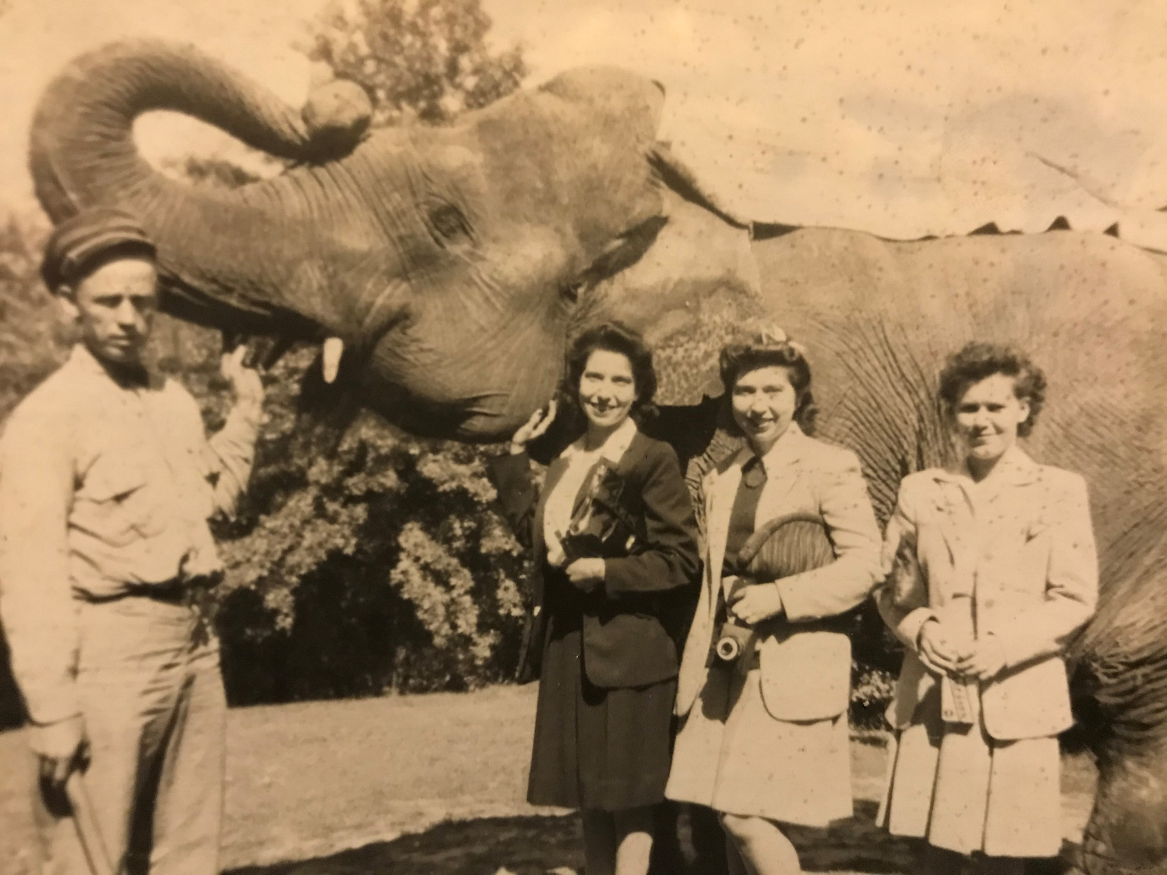

Welcome to the spring edition of the ZAG newsletter. It has been a very challenging 2020 and 2021, but we must remind ourselves zoos are constantly changing and evolving, and so are the ways we do business within our institutions. In the past, zoos had elephant shows and other interactive animal experiences, which most are now considered unsafe for the public, and not healthy for the animals. Today our institutions are still trying to figure out how to keep people, and our collections safe and healthy, while still turning a profit for our institutions. This is a very tricky balancing act in 2021, and change is inevitable, as someday your work will be a reflection from the past. Think about how the future will view your work, and how you managed a pandemic.

The photo above is from the 1950’s and a reflection of how Zoo’s once were in America.

On a positive note, many institutions are now seeing an early economic boom and sales are on the rise. Kudos to all the ZAG buyers that quickly learned to finagle the new COVID World, while keeping employees safe and securing funds for their institutions. All the ZAG buyers deserve a round of applause!

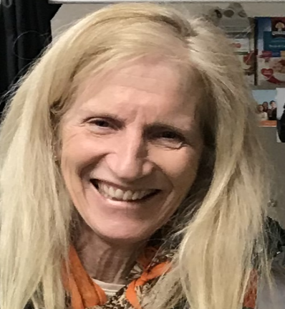 **The** **President’s Message**

By Judy Rancour

Greetings ZAG members! As I write this, we are in the middle of spring break season in my institution – happily, the visitors are coming back (within capacity limits), vaccinations are becoming more available, and product shipments are getting back on track despite lengthy delays at the ports. I have spent the past two weeks in our distribution center helping them get caught up (staffing shortages!), but there are many positive signs in all category of sales, so well worth the extra effort. I’m feeling optimistic that we’ll have a good season, so looking for ways to leverage any bright spots in our assortment performance!

There is change within our ZAG board as we say farewell to Steve Fairchild of the Sedgwick County Zoo in Topeka, Kansas as a long time board member. Steve was one of the founding ZAG members, and has contributed much to the organization over the years. We wish Steve all the best and are so grateful for his time and talent! Replacing Steve is Emily May from the Columbus Zoo in Columbus, Ohio. Emily brings a fresh perspective to our ZAG group and will be working on our social media platform as we gear up for show season. We are delighted to welcome Emily as we grow ZAG in the coming year.

Lastly, I am hopeful we will find reasons to travel to trade shows once again this year. While virtual shows and vendor meetings are helpful, I find the face-to-face aspect of a trade show much more appealing and look forward to seeing vendors and fellow buyers in the fall. We are discussing possible travel support with our many trade show partners, so look for information in the coming months of promotions to ease the financial expense of travelling to a show.

Have a Great Spring Season,

Judy

** Saving Wildlife One Dollar (or Button!) at a Time**

*I asked Dr. Rich Bergl, Director of Conservation, Education and Science at the NC Zoo to speak on how the retail division in your facility can make a huge difference…a little a time.*

Zoos and aquariums have made increasing commitments to conservation in recent years. The combined annual conservation contribution of AZA institutions to conservation in the wild each year has increased almost $80 million over the past five years (2014-2019; 2020 data still being tabulated), and is now approaching a quarter of a billion dollars annually. These efforts make a difference for conservation in more than 100 countries around the world and benefit a huge range of species, from gorillas, to penguins, to amphibians, to coral. Some species, the American red wolf for example, would be extinct if it were not for the efforts of zoos and aquariums.

While the conservation achievements of our community are considerable, they have also required significant amounts of work and the development of innovative approaches. In thinking about the conservation work that our institutions do, it is easy to focus on work in the field: zoo scientists collecting data on endangered species, rangers on patrol for poachers, or teachers educating the next generation of environmentalists. However, the unfortunate reality is that none of our conservation work would be possible with the millions of dollars mentioned above. While some zoo and aquarium conservation funds come from large grants or big donors, much of our support is raised a dollar at a time from our guests. Though a dollar might not seem like a lot of money, it is amazing how, when supported by a carefully developed program, individual dollars can really add up.

The North Carolina Zoo, and our partner the North Carolina Zoological Society, started a program of conservation button sales in our gift shops ten years ago. At the time, I was still relatively new at the Zoo and was looking for ways to generate additional support for our growing conservation program. I approached our Retail Director, David Whitaker about this, and proposed the idea of a “round-up” at our gift shops. David was happy to look for a way to help support conservation, but suggested conservation button sales for a dollar each instead. I was very skeptical, thinking “Who wears buttons these days? This seems like a really outdated idea”. But David replied with a simple “trust me”, and I am glad I did.

Over the last ten years, annual button sales have grown from $8,000 to over $80,000. This did not happen by accident. David has progressively fine-tuned the button sales program, adding staff incentives and pairing these with an education program to let staff know what the button sales are going to support. Every year we start the season with a presentation to retail staff describing the Zoo’s conservation work and end with a thank you outlining what the program has allowed us to achieve. Collectively the button sales, along with other retail and vending opportunities, net over $140,000 in support of our conservation program each year.

The money raised by our gift shop is an essential source of support for our conservation work here in North Carolina and around the world. The consistency of funding year to year is invaluable for being able to plan our conservation work and make long-term commitments, something that is essential for conservation success. In addition, the flexibility with which we can spend these funds (as opposed to, for example, grant funding) allows us to react to unanticipated needs and opportunities as they arise.

As a result of this funding, our conservation work has expanded within North Carolina and in multiple countries across the world. In Tanzania, we use satellite tags to track vultures to better understand their behavior and ecology and prevent poisoning. In Namibia, we are using mobile devices and mapping technology to better protect the world’s largest black rhino population. In Uganda, our long-running conservation education program is helping to foster the next generation of local environmentalists. And right here in North Carolina, the Zoo is working to increase the size of wild amphibian populations through a “head-starting” release program. Much of this work would not have been possible without each of those dollars generated from button sales.

While the value of the button sales program for our conservation program has been immense, there is an additional benefit that is not always obvious. For many of our guests, the problems of wildlife often seem far away. Our visitors may care a lot about the plight of endangered gorillas or elephants, but feel like there isn’t anything that they can do to help. The simple act of buying a button empowers our guests to feel like they are in some small way part of the solution. Just by purchasing a single button, our guests can help wildlife on the other side of the world. In many ways it is a simple and straightforward program, but our button sales really are helping to save wildlife from extinction one dollar at a time.

*Thank you Rich.*

*David Whitaker*

*NC Zoo Society*

** Virtual Show Experiences**

By Donna Steakley

**Operating in the new “norm”**

Saying things have changed is a little bit of an understatement; we do what we all do in the industry **-** adapt**.** We all had/have obstacles toovercome and so did our trade show partners.

It was different doing appointments virtually, but if you paid attention, there was a lot to be learned. Clarion Events offered us “The Marketplace.” Something like their “Match” program (which by the way I would highly recommend), you filled out a profile and vendors asked for virtual appointments. The appointments were scheduled at your convenience. ZAG’s own Tommy Brown co-hosted one on “Sustainability in Retail.” Karl Busche (Knott’s Berry Farm) presented two seminars: “E-commerce” and “Just in Time Production.” With the cutbacks, I know none of us really had time to sit and watch them live; I am lucky enough to have two screens and I watched as I was working. I could not give it my full attention, but I would hear something and totally stop what I was working on to watch the seminar; yes, they all pulled me in. The best part is that they are all recorded; I have placed the links at the bottom of the page. Trust me, they are worth your time.

I want to thank Clarion Events for adjusting to the new norm and coming up with “The Marketplace,” and Tommy Brown, Jerry Wheeler and Karl Busche for giving up their time “to teach an old dog new tricks.” I also want to thank our sponsors, whether you set up on the “The Marketplace,” set up a virtual showroom or took the time to continue to support us, somehow we are getting through this, and together we will! Stay strong and stay safe my friends.

Karl Busche:

E-commerce - <https://youtu.be/VlHPlqABkU0>

Just in Time Production- <https://youtu.be/7XALTDX5jSQ>

Tommy Brown and Jerry Wheeler:

Sustainability in Retail- <https://youtu.be/XdBU7UGV3YA>

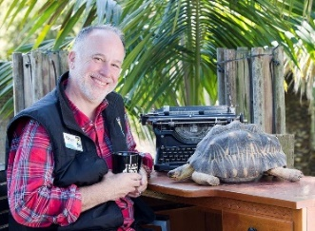

**The Importance of Making Yourself Invaluable to Your Organization**

By Ross Reed Beardsley, Santa Barbara Zoo, CA

Over the years many of our colleagues have been replaced by corporations, or “concessionaires,” that take over the retail operations and, oftentimes, the food service. Unfortunately, those colleagues lose their jobs and the work that they had a deep passion for. In my personal experience, there is nothing quite as rewarding as retail in a conservation environment. I know many of you feel the same because I have seen what you do firsthand. One important way to combat this happening to you is to make yourself invaluable in the eyes of the decision makers. This means going above and beyond your beautifully-merchandised store and the profits you contribute to the bottom line.

I am referring to participating in, leading or initiating activities that have nothing to do with your specific department nor are mentioned in your job description. For example, committee involvement, planning and execution of special events, etc. At my zoo, among other things, I am charge of every aspect of our uniforms for the entire zoo. I know many of you are already doing this and, at a smaller zoo like mine, one must wear many hats.

In the past few years, the leadership of our zoo has changed to prepare for the retirement of our CEO and our director. As a result, I have been serving under a new supervisor. I previously worked for smaller organizations and was directly reporting to the owner or president. With this new supervisor, there is now a level between me and the executive team. I don’t interact with them as much as I used to; mostly, all they see are my numbers. I’ve had to ask myself, “What can I do to make myself visible to them? What can I do to make myself indispensable?”

Recently during this transition of leadership, the CEO of our Zoo (someone I am friendly with and go out to lunch with occasionally) told me, “Your unique voice is very important to us here at the Zoo.” I have given that a lot of thought in the context of keeping my job. As long as I continue to make my voice important, I will continue to be an important member of the Zoo management team.

I stepped up my game. I asked myself, “Am I doing enough of the things that matter to the Zoo? What specifically am I doing that is being “seen” by the “higher-ups?” I have been asked to make presentations to the Zoo’s Board of Directors in relation to retail operations once or twice in the last 17 years. But I have never *asked* if I could make a presentation at a board meeting.

I have thought deeply about what I bring to the table. What are my strengths and passions, and where can they best fit in to our culture at the Zoo? As a result, I have bowed out of some committees that I have no passion or expertise for…and what a relief! I then committed myself deeper to other activities like the Zoo’s diversity, equity, accessibility and inclusion (DEAI) team. That’s an area to which I can speak and my passion drives me to participate more.

In conclusion, it’s just a good idea to make sure your value is seen within your institution. It took a shakeup in management to get me to reflect on the value of the contribution I was making to my Zoo. It resulted, ultimately, in me “getting my groove back.”

I’d like to hear from you. Have you had a similar experience? Or, what are you doing to keep the corporate “wolves” at bay? Email me at [rbeardsley@sbzoo.org](mailto:rbeardsley@sbzoo.org). Happy retailing!

Here is the presentation I did about pronouns representing our DEAI committee. It was to my fellow directors and the executive team.

What's Your Pronoun? Strategies for Inclusion in the Workplace

We start with a communication plan to thoughtfully inform individuals and address initial questions about pronoun inclusivity.

SAMPLE STATEMENT "As part of our ongoing efforts to be inclusive of all gender identities, we are pleased to confirm that anyone wishing to do so may add pronouns to their email signature, business card, and/or nametag. Adding pronouns has the practical benefit of making clear how you would like to be referred to, while also normalizing to the recipient that you will respect their identity and choice of pronouns: that you are an "ally." It helps to normalize discussions about gender and helps to create an inclusive work environment for transgender and non-binary people."

Overview

Making the wrong assumption about someone's gender identity or expression, and, by extension, their pronouns, can be insulting, harmful, and if done repeatedly, constitute workplace bias or harassment. Pronouns are tied to our deepest sense of identity. Imagine being called by the wrong name despite having introduced yourself. Does the person not care enough to know you? Using inclusive pronouns in the workplace builds a culture of respect and belonging not just to the LGBTQ community, but for anyone who in some way does not fit the traditional model of gender identity and expression.

Why now?

Gender is more expansive than ever. There are an estimated 1.4 million transgender Americans. 1 in 3 adults knows someone who uses gender-neutral pronouns. Nearly 1/2 of Americans see gender on a spectrum and see the necessity of using gender-neutral pronouns. Millennials represent the largest part of the American workforce and are known to be more open-minded, inclusive, and show higher rates of LGBTQ identity.

Employees look for gender-inclusive practices.

The majority of Americans support gender inclusivity. 59% of Gen Zers believe that forms and/or online profiles should include gender options other than 'man' or 'woman.' A 2018 Harris Poll survey found: 74% of respondents believe that employers should learn and use employees' pronouns and chosen names; 65% believe an employer should intervene when another employee regularly misuses another employee's pronouns or chosen name. 58% believe that regular misuse is a form of workplace harassment

Inclusivity improves business and inclusive pronouns are key.

Research consistently shows that LGBTQ-inclusive workplace environments generate increased performance, productivity, retention, talent, and well-being. Younger generations actively seek employment at companies that share their own values of inclusion and that facilitate connected cultures of belonging.

Pronouns Matter

Using a person's proper pronoun makes a difference in the mental health and well-being of everyone, particularly transgender/GNC employees. When a person is misgendered, it can cause dysphoria, anxiety, stigmatization, lowered self-esteem, and embarrassment Gender-affirmative support can have a powerful, perhaps, lifesaving impact. It can reduce depression, improve self-esteem, and create a better quality of life for transgender/GNC individuals.

Sample Pronouns

He/She/They/Ze/Ze Him/Her/Them/Hir/Zir His/Hers/Theirs/Hirs/Zirs

Sample formal address

Sir/Ma'am/Miss/Ladies/Gentlemen Mr./Mrs./Ms./Mx.

Other terminology besides Guys, Hey guys, You guys, Hi guys

Consider using: All of you, Colleagues, Everyone, Valued guests, Friends, Team, Folks

Terms

LGBTQ - Lesbian/Gay/Bisexual/Transgender/Queer or Questioning

Transgender

GNC - Gender Non-Conforming

Ally

Suggested changes we make in our organization: in the hiring process, internal forms and records, email signatures, and nametags.

All paperwork provides an opportunity to voluntarily declare pronouns and chosen names. Include gender identity options other than male or female.

Offer to list as Mr./Mrs./Mx.(mix)

Provide general gender identity/expression training for staff so they can understand the basics and not misgender their co-workers or our guests. Could be added to NEOP.

In review, we develop a communication plan to thoughtfully inform individuals and address initial questions about pronoun inclusivity.

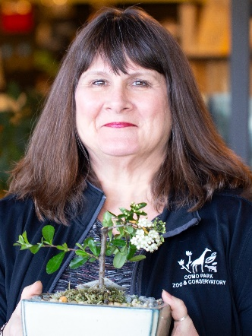 **The ‘G’ in ZAG**

Terri Scheunemann – Como Zoo & Conservatory

ZAGs mission is to increase communication and networking opportunities between merchandise buyers in the zoo, aquarium and garden industry so that through sharing information members may operate their gift shops more profitably for their facilities.

In 2018, ZAG membership voted to change the G in ZAG, to represent Gardens. It was a natural progression of the original mission of ZAG to bring gardens into our membership.

**Why should a garden buyer join?** Your membership is free! In joining ZAG you become one of more than 400 people from over 300 facilities throughout the world who make up our members. Only buyers from independent retail operations are eligible for membership. ZAG’s activities are entirely funded by our vendor sponsors.

**ZAG Sponsors and Partners.** The vendors who join and become our sponsors wish to target our specific retail industry. The funds from their memberships support the work of ZAG. It pays for our annual business meeting, supports the operating costs of the organization such as board costs & web site (zaggift.com), funds the cost of presentations at AZA, National Shows and Marketplaces, and helps to pay for yearly scholarships for buyer members to attend trade shows such as Las Vegas & Atlanta Markets, Las Vegas Souvenir, Smoky Mountain and IGES shows.

Many of us are members of organizations such as APGA (American Public Gardens Association), AZA (Association of Zoos and Aquariums), ZAA (Zoological Association of America), MSA (Museum Store Association). ZAG, unlike the many of these, is specifically for independent retail buyers and is no cost to you or your organization.

If you are a retail buyer, join ZAG and take advantage of this group of like-minded, dedicated retail professionals who will share ideas, contacts, and assist you to improve your business!

**What is the 80/20 Rule?**

**What do your inventory levels look like beginning a second COVID-19 season for Retail?**

**Has anyone ever heard of the old retail term, the 80/20 rule? And exactly what does this mean?**

* **80% of the sales come from 20% of the inventory that gift shop carries.**

Why may this be an important strategy to consider when starting off the new season?

* Many of us are being careful with cash flowing out of the organization with limited revenue coming in.
* Remember, the new products you bought last year will still be new this year to many of your guests this coming season.
* 80% of your profits come from 20% of your inventory.
* **The 80/20 rule plays significant role in our business objectives: Turnover, Gross Margin, Inventory and Cashflow.**

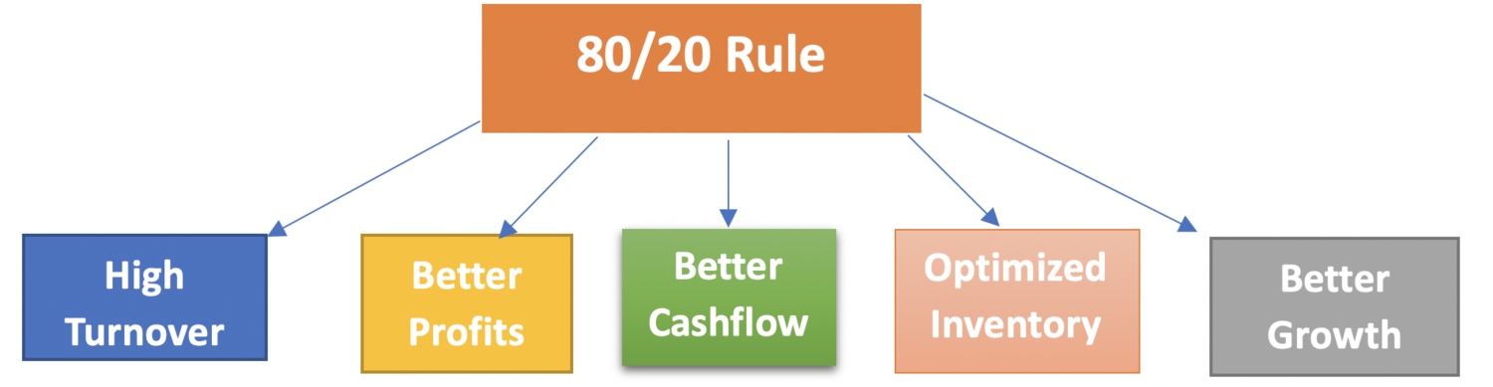

**What does the 80/20 rule mean in your inventory management?**

* By turning the inventory quickly, we can, in many cases, pay for that inventory with the sales.
* Your top products should be top of mind because they bring in most of your profits.
* Your top sellers should be easy to reach and placed in featured positions in your shops. You should constantly monitor these items and ensure you maintain appropriate inventory levels.

**How can our vendor partners help?**

* Reach out and have conversations with vendors on their best-selling items in your top categories to make sure you are maximizing the potential.
* For example, your best-selling plush categories are penguins and giraffes. Vendor A tells you that 70% of Giraffe sales and reorders are from sku XYZ and 68% of Penguin sales are from sku ABC. You already carry these sku’s and they perform well but they are merchandised in the aisle. Can you move them to a front endcap to capitalize on the potential?
* We cannot be experts on everything happening in the gift shop market. Our partnership with vendors is our lifeline to keep up on industry trends.
* So, are new items a bad idea this year and so I should not buy? Absolutely not. In tough times, by adding new items into your best-selling categories you can drive positive results. Make sure you are keeping within your budgeted purchase goals and not sacrificing proven winners.
* Make sure you are having conversations on product availability. Covid-19 has also had an impact on the manufacturing sectors of our industry. By asking about inventory availability for the season, you may be able to plan and understand what will be available when the peak season arri

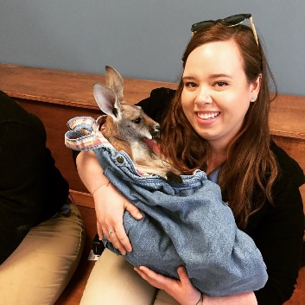**Tech Talk with Emily**

By: Emily May

**Scheduling Apps: Should You Be Using Them and What Do They Offer?**

Whether you are scheduling 15 people or 150 people (like myself) scheduling your staff and staying within your labor budget can be quite the challenge. While there are many methods to scheduling, using scheduling apps available online and on your smart devices may help you get as organized as possible when working around employee’s other job schedules or school schedules. I’ve personally worked with 3 scheduling apps, all with pros and cons: When I Work, Jolt Up, and 7Shifts.

Something important to consider when looking into scheduling apps is how many employees you will be scheduling and using the app.

* Some scheduling apps have free versions you can utilize up to a certain number of employees
  + These are useful if you only have a handful of people to schedule
* Other apps charge per person (like When I Work)
  + This can get expensive if you or your organization schedule hundreds of employees
* Apps, like 7Shifts, charge per department/organization/location
  + This is the best option if you have many people and departments that will be using the app to schedule employees

I’m currently scheduling with 7Shifts, and although this was mainly created for the food and beverage industry, we have been able to utilize the app for many departments (Retail, Food and Bev, Admissions, Rides, etc.) all over our Zoo and waterpark.

Of all of the apps I have used, 7Shifts has been the most cost effective with the best features. Here are some features I find most helpful:

* Employees can put in their own **availability** – Sunday-Saturday, full days and partial days, repeating every week, or individual week availability
* They can also request **days off** for approval – these can be full day or partial day requests

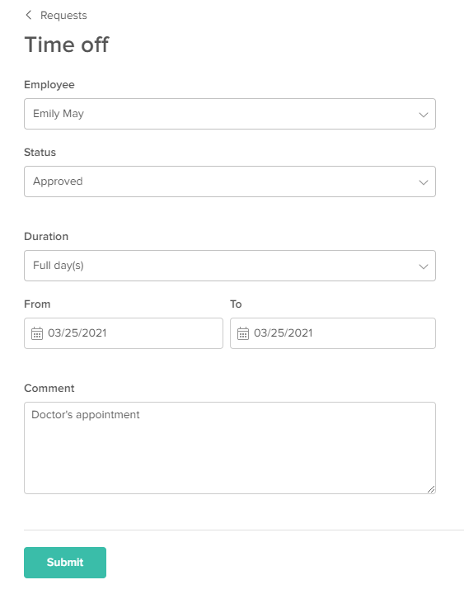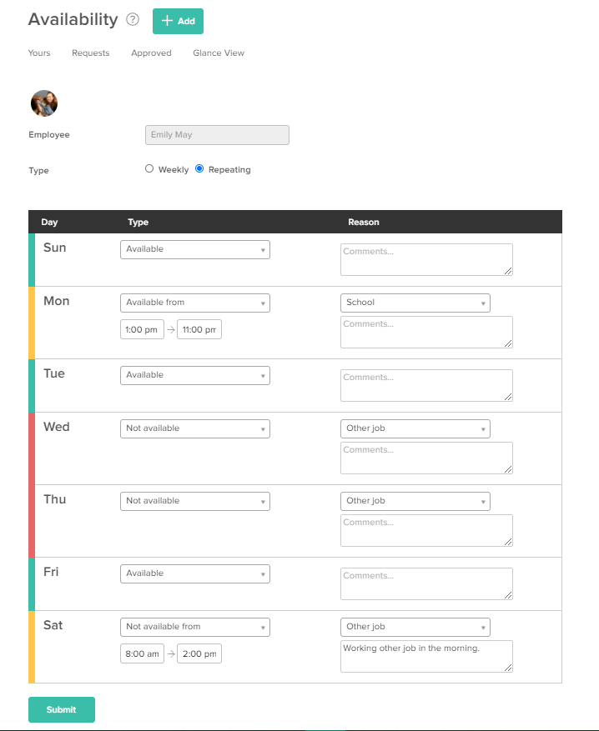7Shifts offers a **Shift Pool**

* + Employees can drop shifts and pick up shifts other employees are trying to get covered
  + They also have the option to pick up Open Shifts you’ve created on days you may need extra help
* You are able to enter **projected labor spent** and projected sales
  + 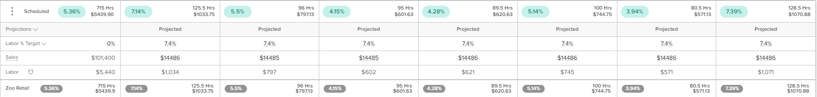When creating new employee accounts, you can enter their wage to help predict how much you will be spending on labor on a given day or week
  + If you are working with a labor/sales percentage, you can enter potential sales to stay within that percentage
    - Depending on your POS system, you can even connect your POS system to the app so you have real-time sales history in conjunction with your predicted labor
* There is an **Announcements** feature to send one way communication to all staff or specific departments
  + I use this feature to share important events happening on grounds or share upcoming promotions in our stores so employees can share this with guests

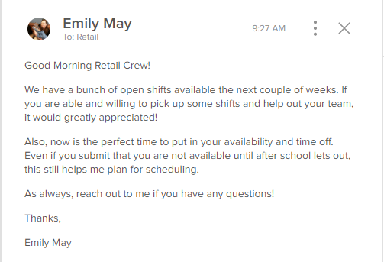

* The **Messaging** feature is a way to create a conversation with one employee or a group of employees
  + This is great for asking specific availability/time off questions
  + Employees can also message you with any questions they may have
* I utilize the **Events Calendar** feature quite a bit help myself schedule for special events, plus employees can see these to stay informed
* There is a **Templates feature** if you know you will always have openers, mid-shifts, and closers
  + You can enter the roles you need during the week, and times
    - From there, you just drag and drop the shifts to the employees available to work
* You can also **copy a schedul**e from a previous week
  + This is great if you know the week before will be similar to the week you are currently working on
* **Weather predictions** are available a couple weeks out
  + This helps if you know it’s going to be a nice day and busy in your park, you can add a couple available employees to the schedule
* 7Shifts has an **app for Android and iPhone**
  + They can send push notifications for various postings, so there is no real reason an employee shouldn’t know they are scheduled on any given day
* My team leads utilize the **Log Book** feature to share what happened in our department that day
  + This could be call offs, employee shout outs, tasks that need to be completed, etc.
    - This helps management and their fellow leads stay up to date with the daily operations of the Retail Department

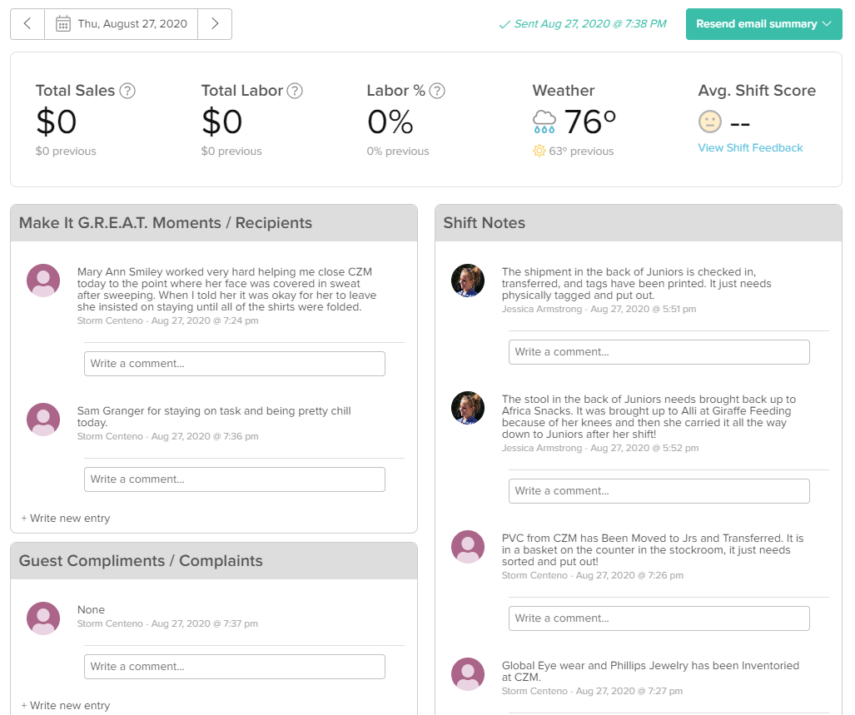

**The Bottom Line:**

* Scheduling apps create a platform for employees to submit their availability so you can see it all at once while working on your schedules throughout the year
* There are many tools available on the 7Shifts app to help you and your employees, such as: The Shift Pool, Availability/Time Off Requests, Labor tools, and a daily Log Book
* Different apps offer different features and pricing, you just have to find the one that works for your establishment

Other than 7Shifts, Jolt Up, and When I Work, here are some other apps to consider:

* Humanity, When To Work, Hot Schedules, Zoom Shift, Sling, and Homebase

**New Member Spotlight**

by Sheila Wewers

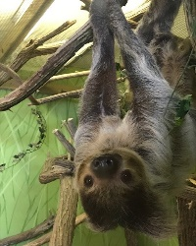The start of 2021 brings a new “normal” as we welcome 12 new ZAG members! Although not an official ZAG member, Hilary Tierney’s sloth buddy Duffy lives across the lobby from her gift shop and keeps her company after hours while she stocks the store. Don’t we all have a buddy like Duffy to keep us motivated?!

**Mallory Daschke** is a new Retail Manager and Buyer at John Ball Zoo, the fourth most attended cultural facility in Michigan, and is originally from Novi on the east side of Michigan, near Detroit. As the buyer, Mallory enjoys that her position allows her the ability to focus on sustainable and eco-friendly products from Green Vendors. She appreciates being a part of the bigger picture of John Ball Zoo’s overall mission of inspiring the community to be actively engaged in the conservation of wildlife and the natural environment. John Ball Zoo is set to open March 27 when it will restart its path to welcoming 48,000 economically disadvantaged children and adults with free admission and reaching 700,000 people annually with wildlife conservation messages.

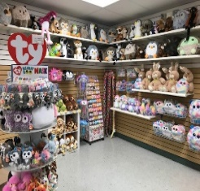**Hilary Tierney** from Henson Robinson Zoo in Springfield, IL not only runs the gift shop but is also the Guest Services and Marketing Manager. Her local, community zoo offers a variety of native and exotic animals, and the small size of her zoo provides visitors a fun and memorable experience without huge crowds or long car rides. Henson Robinson Zoo has recently been awarded a grant for a new African and Asian primate exhibit and Hilary is excited to see that process get started. Hilary wears many hats in her role at the zoo and enjoys contributing to designing exhibiting spaces, scripting and recording zoo keeper chats, and buying for the gift shop. She has found success with Wild Republic’s 54” snakes and Collection Buckets in full and mini sizes. Although she has been with the zoo for four years, this is her first year in charge of buying and she looks forward to expanding the gift shop collection beyond plush and toys to more items with a conservation message or mission like Conscious Step. Hilary has fond childhood memories of spending Saturday mornings watching Mutual of Omaha’s Wild Kingdom.

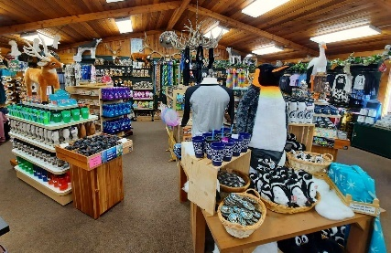**Troy Kravig** sends his greetings from Dakota Zoo in Bismarck, North Dakota. Originally from Indiana, he moved to Bismarck in 2019 to accept a zookeeping position; later that summer he transitioned into his current role as Guest Services Manager. Troy finds his job to be very rewarding and thoroughly enjoys sharing his passion for the zoo’s mission statement in all aspects of his work. Whether selling admission tickets or memberships, purchasing meaningful items for the gift shop, or operating the zoo’s train and concession stand, Troy does all he can to ensure guests have an enjoyable and safe trip to Dakota Zoo. On June 3rd, the zoo will be celebrating its 60th anniversary and although a newcomer to the community, Troy views that milestone as a testament to the support that Bismarck has for its local zoo.  Later this season, the zoo will be opening a state-of-the-art facility featuring African Black-Footed Penguins; do not fret, the zoo’s gift shop is full to the brim with fun penguin memorabilia!

**Welcome the Following New Buyers to ZAG:**

**Buyer**                     **Institution**                                                       **City**                       **Email**

Kayla Spor             Ortaga National Parks                                  Overland Park, KS    [marketing@ortegaparks.com](mailto:marketing@ortegaparks.com)

Lea Jaunakis         Tiger World, Ins                                              Rockwell, NC           [lea@tigerworld.us](mailto:lea@tigerworld.us)

Jeff Mitchell       Saskatoon Forestry Farm Park and Zoo    Saskatoon, SK         [jeff.mitchell@saskatoon.ca](mailto:jeff.mitchell@saskatoon.ca)

Audree St-Onge   Zoo de Granby                                               Granby, Quebec      [astonge@zoodegranby.com](mailto:astonge@zoodegranby.com)

Hilary Tierney       Henson Robinson Zoo                                 Springfield, IL            [htierney@springfirldparks.org](mailto:htierney@springfirldparks.org)

Chris Gurley          Southland Safari                                           Yuma, TN                  [southlandsafari@yahoo.com](mailto:southlandsafari@yahoo.com)

Mallory Daschke   John Ball Zoo                                                 Grand Rapids, MI    [mdaschke@jbzoo.org](mailto:mdaschke@jbzoo.org)

Brian Braitsch       Amazing animals, Inc                                   St. Cloud, FL              [brian@amazinganimalsinc.org](mailto:brian@amazinganimalsinc.org)

Kelsey Keller         African Safari Wildlife Park                        Port Clinton, OH      [sophien@africansafariwildlifepark.com](mailto:sophien@africansafariwildlifepark.com)

Sally Jacobson      Red River Zoo                                                Fargo, ND                 [sally@redriverzoo.org](mailto:sally@redriverzoo.org)

Melanie Mauldin  Highlands, NC Nature Center Gift Shop Highlands, NC      [melaniemaudlin@gmail.com](mailto:melaniemaudlin@gmail.com)

Troy Kravig          Dakota Zoo                                            Bismarck, ND       [office@dakotazoo.org](mailto:office@dakotazoo.org)

**A Special Thank You to Our New ZAG Sponsors:**

[](https://youtu.be/8aGcIhynzxY)

**IMPULSE Souvenirs is happy to be a proud ZAG sponsor in 2021.** We’d like to introduce ourselves as your one-stop ‘Original Art’ souvenir source. Every zoo, aquarium, and garden is unique. When items in your gift shop showcase your “uniqueness” visitors will remember their experience fondly.

Work with our subject-matter experts to get the dedicated attention of souvenir specialists with 20+ years of experience who develop custom, one-of-a-kind quality souvenirs that sell and merchandising displays that deliver turnover. Our veteran sales staff partners with you, listens to you, and thoroughly understands your one-of-a-kindness. Then, we work internally with our talented designers to create ORIGINAL ART that captures and conveys your location’s particular experience!

As owners of our own production factories, we oversee your souvenirs from concept through retail-ready packaging, governing the entire manufacturing process end-to-end to guarantee the highest quality. Contact us today for a free sample kit that showcases our product quality and original art for patches, pins, stickers, keychains, safety masks, quality branded apparel, magnets, displays, and more!

[www.IMPULSEsouvenirs.com](http://www.impulsesouvenirs.com)

[service@impulsesouvenirs.com](mailto:service@impulsesouvenirs.com)

(253) 248-0096  
**VIDEO LINK:** [**https://youtu.be/8aGcIhynzxY**](https://youtu.be/8aGcIhynzxY)

[](https://linkprotect.cudasvc.com/url?a=http%3a%2f%2ftoplineproducts.com%2f&c=E,1,9dWhr0ohtWXYUzA2soSVqv0gKQ8SJ7sDKF58sj2qJ7NxN8lDA7iZn0hOBP8B06KnC2lWy1Ji_z2pbfSlDvdOnr9ODU5tK8X4x8gauJNigLA,&typo=0)

We specialize in pad-printing name drops in the US on a variety of in-stock low minimum items: Waterglobes, Liquid Timers, Kids Pens, Magnets, Key Holders, Ornaments, Binoculars, and Trinket Boxes. Also able to bring in Custom designs from our vendors overseas with low minimums and a speedy turn around time from sample to production!"

Was not sure exactly what was needed for the description, but I believe the above text sums us up. Let me know if I need to add anything or mention any trade shows we exhibit at.

Thank you,

James Linhoff